Title: Temple plan. नीरजा (Neerja - Born of Water)

Materials: Fabric/Kesa 215/130cm
Japanese cedar 227/21cm overlaid with 24 carat gold leaf, plus Dutch gold leaf; inlaid with temple hair
Burnt wooden bowl

Craig, as with newer work I have included a short blurb. For the above please include this,

Temple prayer: Now as we are being shaved, let us pray that we may leave behind world desires for eternity, after all neither birth nor death exist.

_____________________________

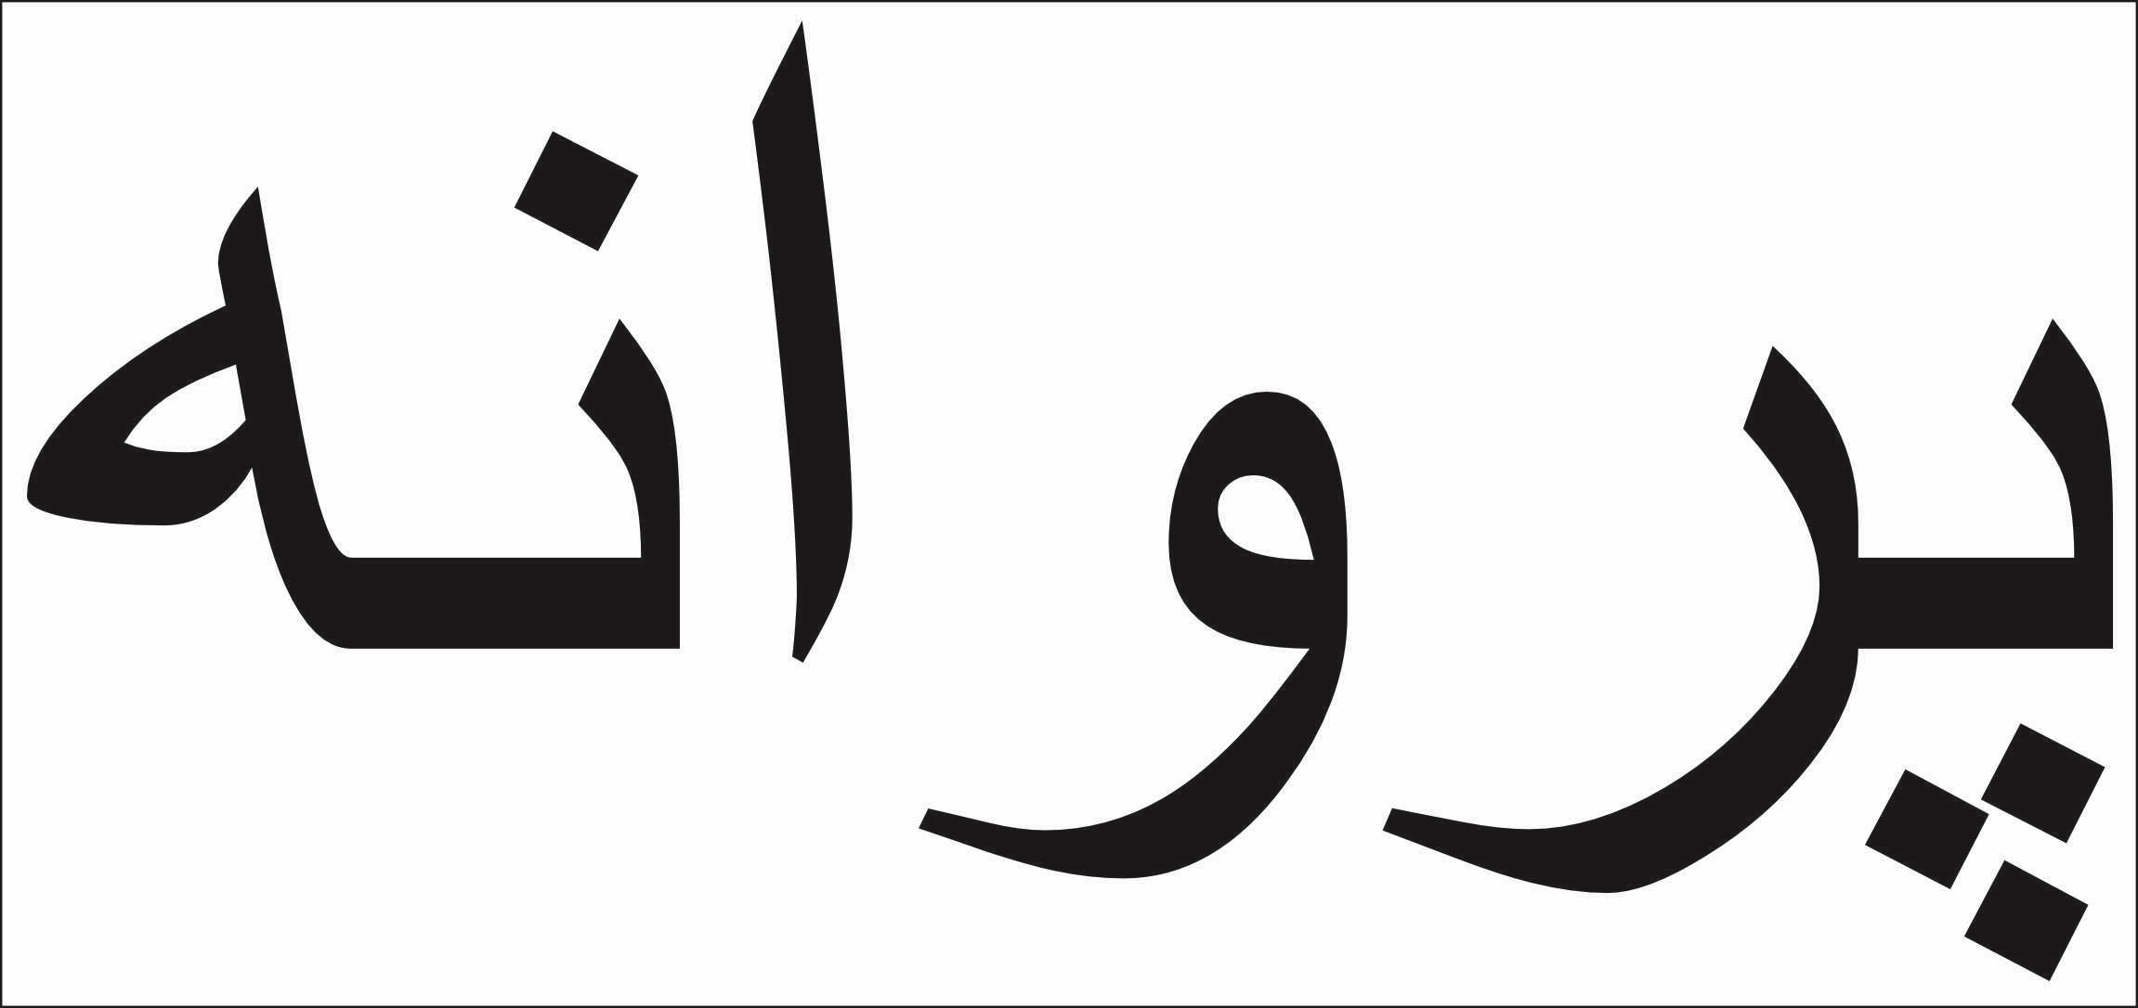
Title: Our Ceiling Fell Apart

(Butterfly - Parvaneh)

(CRAIG, THE SECOND NAME IN FARSI IS A SCREEN SHOT.
DO THINK IT POSSIBLE TO CREATE A TEXT FOR IT? AS JUST USING THE SCREEN SHOT MAY BE DIFFICULT ON THE WEBSITE).

Materials: Fabric/Kesa 215/130cm
Stone Circle
Head resin, wood from burnt child’s chair, charcoal.
Leaves brass and cupric nitrate.
Brass finials
Burnt Japanese cedar

Craig, as with newer work I have included a short blurb. For the above please include this,

In the burning, the destruction and the bombing, her roof fell down. A hell realm lasted for an eternity. She couldn’t breathe. I have no idea what made her smile.

_____________________________

“View all.” - Is this not working just yet?

_____________________________

When searching on the web it says South African artist sculptor. Ideally it should just say South African / UK artist (no need to say ‘sculptor’)

If you go to the about section it says, “South African artist and sculptor working between Port Elizabeth and Cape Town.”
So again it can just say, South African / UK artist

Again, at the beginning of the about section its says, “Richard James studied sculpture at Central Saint Martins in London, spent seven years as a Zen monk, and later trained in psychology”
Can we change that to, “Richard James studied sculpture at Central Saint Martins in London, spent seven years as a Zen monk, seven years teaching children and later trained as a counsellor” ?

Then delete, “His background also includes work as a counsellor”

_____________________________

At the bottom of all pages (I think) it says,
South African Artist and Sculptor. Please can we change this to just, “South African/UK artist”. ?

We can also delete “STUDIO — PORT ELIZABETH & CAPE TOWN,” writen bottom right of all pages.

______________________________

On the ‘Contact’ page at the bottom it says, BASED IN Port Elizabeth & cape Town.
Let’s just write, Gqeberha (Port Elizabeth), South Africa.

–––––––––––––––––––––––––––––––

Black Photographs and ‘Poems’

It’s not clear which text goes with which photos. Eg as we scroll down we see two photos and the text next to them, which in that photograph says, ‘throat and room’. But the frame next to it reads ‘throat and Room’

Can we do something about this ? I.e. throughout this section.
I think given the much larger size of the photos in proportion to the text, it will be helpful if the photos spanned the screen when viewing.
We could then have the text as a quarter of the screen, just underneath the photos, which will be enough to inform the viewer what the text says.
I am open to other ideas though.

It should be obvious to the viewer that each two photos has a text (and in some a duplicate text) next to the photo. What we then want to inform the viewer is exactly what that text in the picture says.

Also bear in mind that if it says ‘cynic cynic’, that’s the one that needs to be enlarged jester as out is in then next frame.
___________________________

I know some of these photos are replicas of each other. In the editing phase please can you rotate them around so that in one we may see this, in the next this:
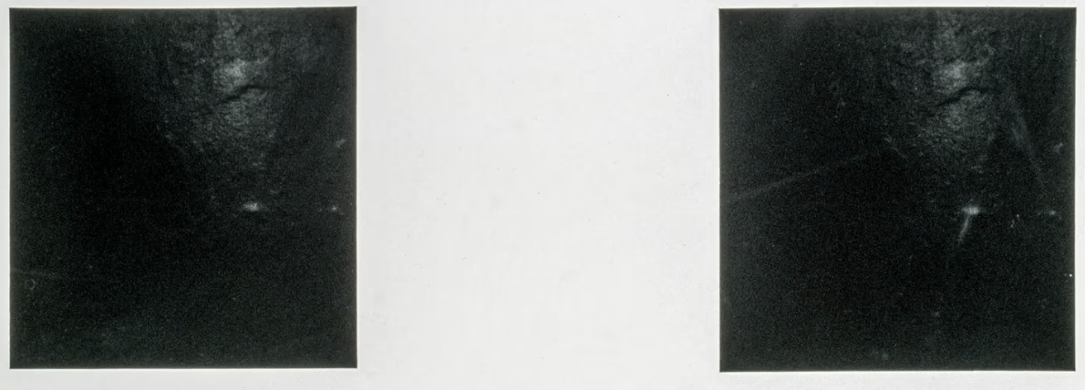


In places it would be helpful if you can rotate a single square by cutting it out, rotating it and ending up with this:
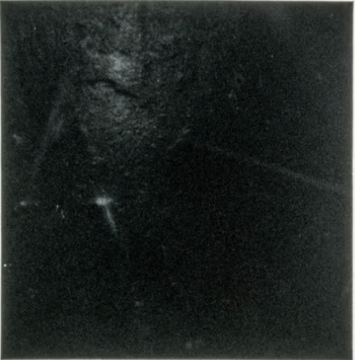


____________________

Finally Craig: when I move left and right on the black photos it’s not fluid. I know this version of the site is not yet finished, but thought I’d mention its here

